Reins of Change Presents…

Corporate Training and the

EAGALA Approach

“It Takes a Team to Build a Team”

An EAGALA Sponsored Workshop at Reins of Change, Center for Equine Assisted Growth and Learning

Learn how to effectively utilize the EAGALA Approach in your corporate training sessions. Discover how horses can help your team to create positive, lasting change in corporate groups.

Topics include: the basics of setting up your own corporate training program, selecting the most appropriate staff, boundaries and other ethical considerations, planning your curriculum, and marketing ideas to help you get started! Equine activities are held throughout the two-day workshop so you can also learn from our most valuable staff members, the horses.

2006 Workshop dates: March 24-25 and September 27-28
(ask us about our other EAGALA Sponsored Workshops)

Presented by Reins of Change Corporate Training Staff:

Amy Blossom, Equine Specialist, EAP III
Brenda B. Hunter, MA, LCPC, EAP II
Mandie C. Cummins, MHRD, EAP I

Reins of Change, Inc.
9N623 Kendall Road
Elgin, Illinois 60123

Phone: 847.464.5177  www.reinsofchange.com  workshops@reinsofchange.com
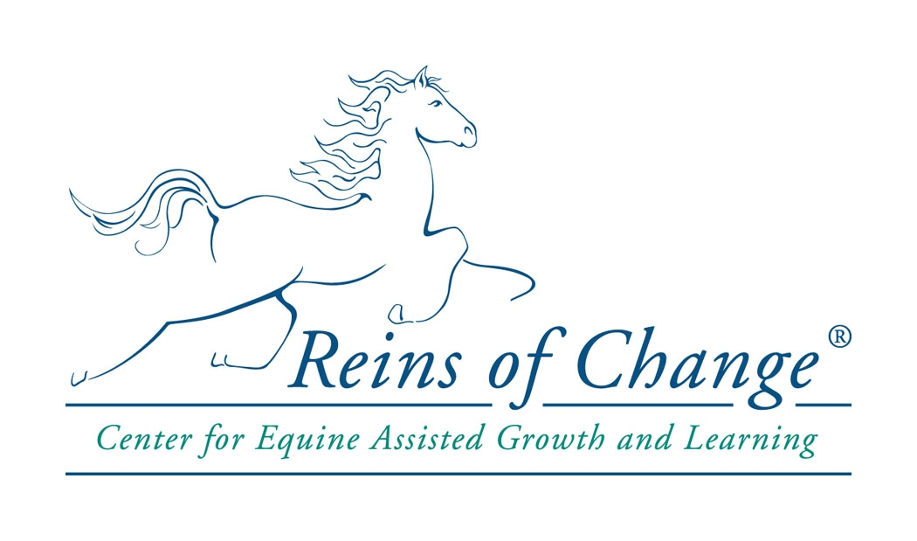
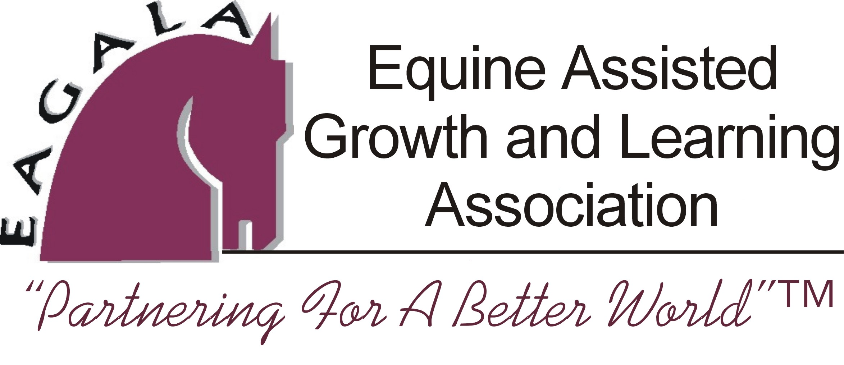

Corporate Training and the EAGALA Approach
Reins of Change, Center for Equine Assisted Growth and Learning

Workshop Registration Form

2006 Workshop dates: March 24-25 and September 27-28
(ask us about our other EAGALA Sponsored Workshops)

Name(s) of participant(s): ________________________________________________________________________

Credentials and EAGALA Certification Level:
________________________________________________________________________

Organization: ____________________________________________________________

Address:________________________________________________________________

Phone: _____________________________ Fax: _________________________

E:Mail: ______________________________ Other:________________________

Briefly explain your interest(s) in this particular workshop:
__________________________________________________________________________________________________________________________

Fees: $350 per person – Please pay 50 % deposit to register.
Group discount: $325 per person if 2 or more from the same organization

Continuing Education Credits: There is a $10 additional fee for CEU certificates.

Cancellations: A refund, minus a $50 administrative fee, will be given for cancellations made within two weeks of the workshop.

This EAGALA Sponsored Workshop qualifies for EAGALA re-certification credits, continuing education requirements, and counts toward Level II and Level III criteria. Participants must have minimum EAGALA Level I certification, and be current members of EAGALA to attend this workshop.

Mail checks to: Reins of Change, 9N623 Kendall Road, Elgin Illinois 60123
Phone: 847.464.5177 Fax: 847.464.5172 e:mail: amy@reinsofchange.com

Bring EAGALA Sponsored Workshops to your own organization.
Contact Amy Blossom at Reins of Change for more information.

