Reins of Change Presents…

UnNatural Horsemanship and the

EAGALA Approach

“Developing the art of Un-instructing”

An EAGALA Sponsored Workshop at Reins of Change, Center for Equine Assisted Growth and Learning

- Learn how to effectively utilize the EAGALA Approach as an equine specialist.
- Fully utilize your equine mirror(s) through personal awareness and team support.
- Develop stronger observation and processing skills.

Topics include: How to look into the equine mirror, benefits of groundwork and EAP, un-instructing for safety, developing your team, self-awareness in the arena, choosing horses for your activities, and experiential learning vs. teaching. Equine activities are held throughout the two-day workshop, so you will also learn from our most valuable staff members, the horses.

2006 Workshop dates: May 26-27 and July 21-22
(ask us about our other EAGALA Sponsored Workshops)

Presented by Reins of Change Staff:
Amy Blossom, Equine Specialist, EAP III
Brenda B. Hunter, MA, LCPC, EAP II
and Guest Presenter from Sierra Family Services:
Mickey DiGiacomo, Equine Specialist, EAP III

Reins of Change, Inc.
9N623 Kendall Road
Elgin, Illinois 60123

Phone: 847.464.5177  www.reinsofchange.com  workshops@reinsofchange.com

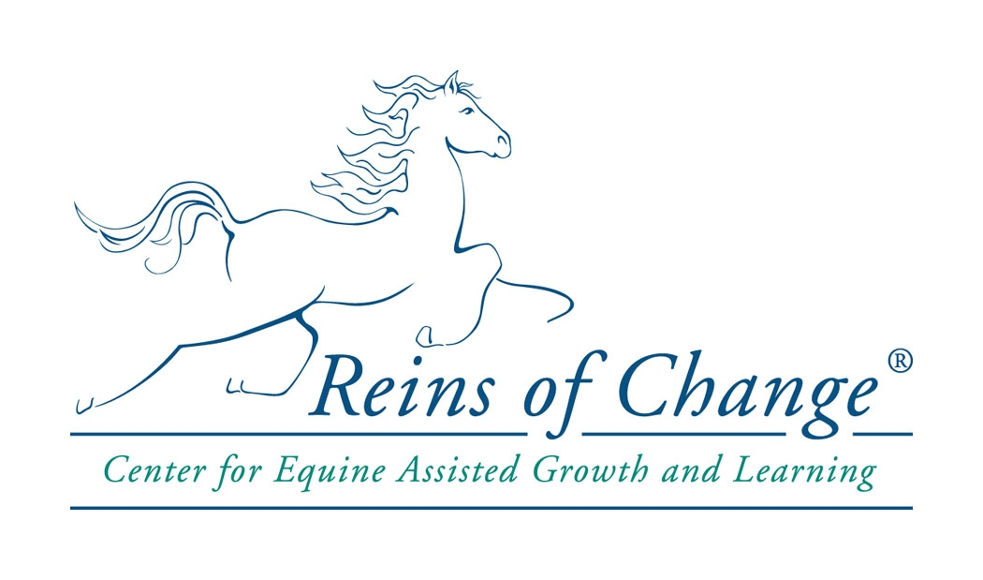
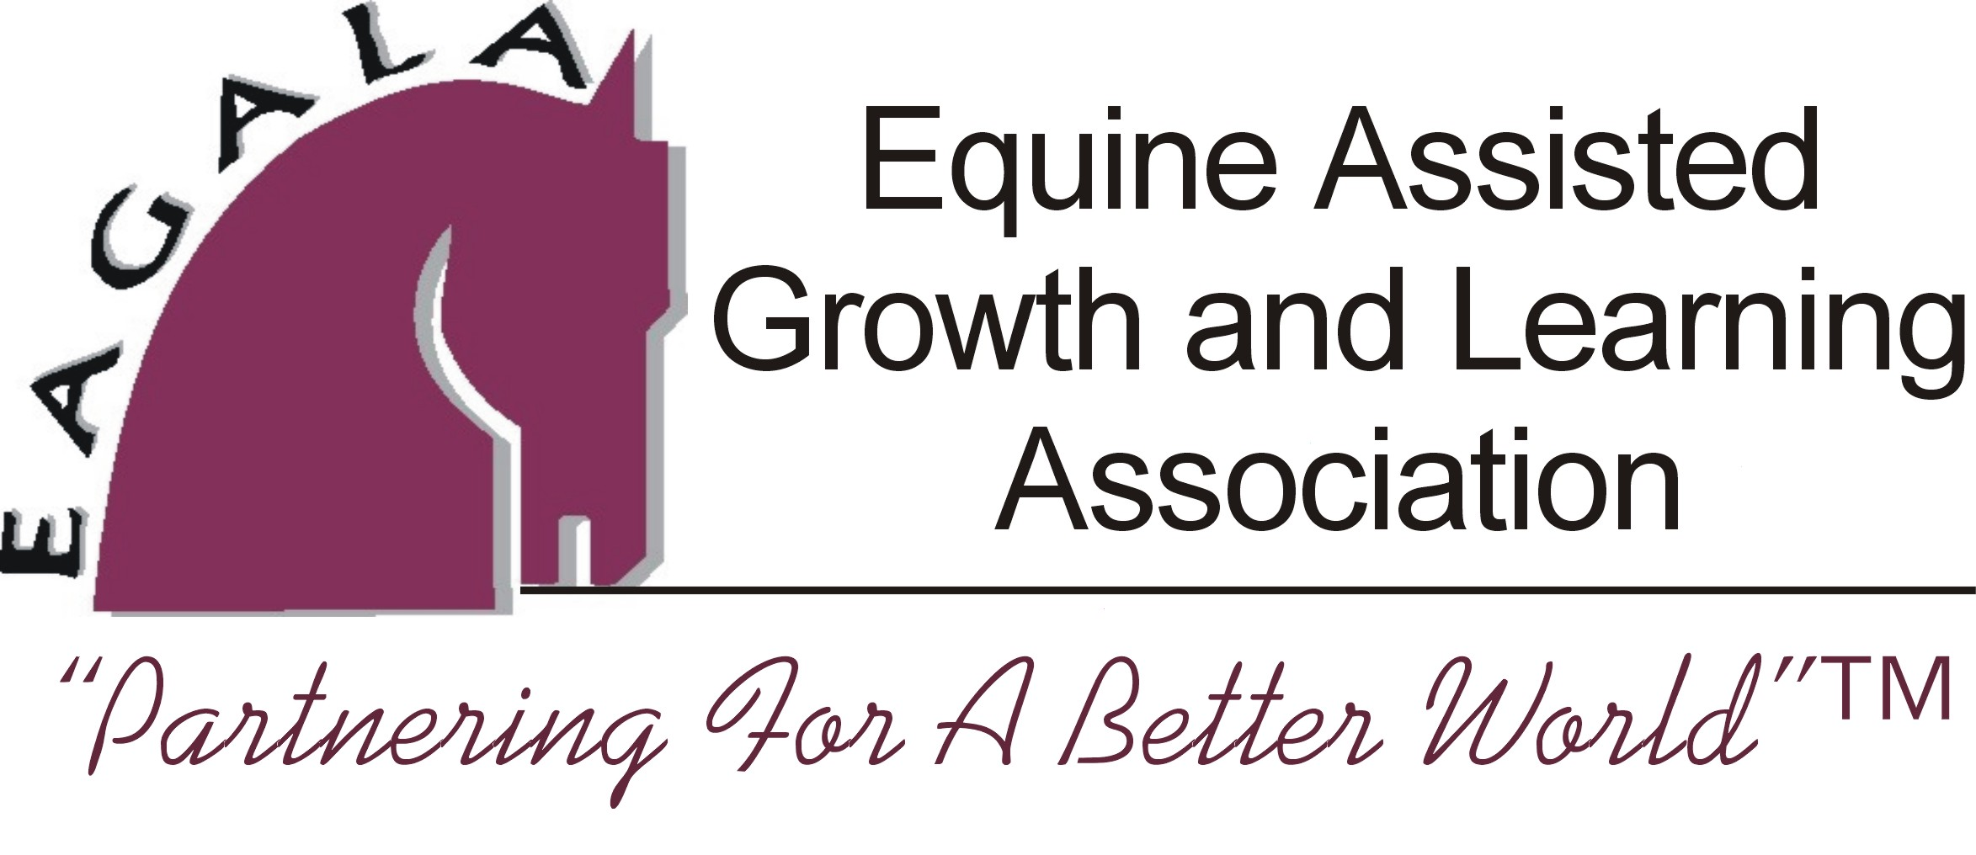
UnNatural Horsemanship and the EAGALA Approach
at Reins of Change, Center for Equine Assisted Growth and Learning

Workshop Registration Form

2006 Workshop dates: May 26-27 and July 21-22
(ask us about our other EAGALA Sponsored Workshops)

Name(s) of participant(s): ________________________________________________________________________

Credentials and EAGALA Certification Level:
________________________________________________________________________

Organization: ____________________________________________________________

Address:________________________________________________________________

Phone: _____________________________ Fax: _________________________

E:Mail: ______________________________ Other:________________________

Briefly explain your interest(s) in this particular workshop:
__________________________________________________________________________________________________________________________

Fees: $350 per person – Please pay 50 % deposit to register.
Group discount: $325 per person if 2 or more from the same organization

Continuing Education Credits: There is a $10 additional fee for CEU certificates.

Cancellations: A refund, minus a $50 administrative fee, will be given for cancellations made within two weeks of the workshop.

This EAGALA Sponsored Workshop qualifies for EAGALA re-certification credits, continuing education requirements, and counts toward Level II and Level III criteria. Participants must have minimum EAGALA Level I certification, and be current members of EAGALA to attend this workshop.

Mail checks to: Reins of Change, 9N623 Kendall Road, Elgin Illinois 60123
Phone: 847.464.5177 Fax: 847.464.5172 e:mail: workshops@reinsofchange.com

Bring EAGALA Sponsored Workshops to your own organization.
Contact Amy Blossom at Reins of Change for more information.

